**Task 1**

**Input:**

from OpenGL.GL import *

from OpenGL.GLUT import *

from OpenGL.GLU import *

import random

def draw_points(x, y):

glPointSize(3)

glBegin(GL_POINTS)

glVertex2f(x, y)

glEnd()

def iterate():

glViewport(0, 0, 500, 500)

glMatrixMode(GL_PROJECTION)

glLoadIdentity()

glOrtho(0.0, 100, 0.0, 100, 0.0, 1.0)

glMatrixMode (GL_MODELVIEW)

glLoadIdentity()

def showScreen():

glClear(GL_COLOR_BUFFER_BIT | GL_DEPTH_BUFFER_BIT)

glLoadIdentity()

iterate()

glColor3f(0.8, 0.2, 0.2)

for i in range(50):

x= random.randint(0, 50)

y= random.randint(0, 50)

draw_points(x, y)

glutSwapBuffers()

glutInit()

glutInitDisplayMode(GLUT_RGBA)

glutInitWindowSize(500, 500)

glutInitWindowPosition(0, 0)

wind = glutCreateWindow(b"Question 1")

glutDisplayFunc(showScreen)

glutMainLoop()

**Output:**

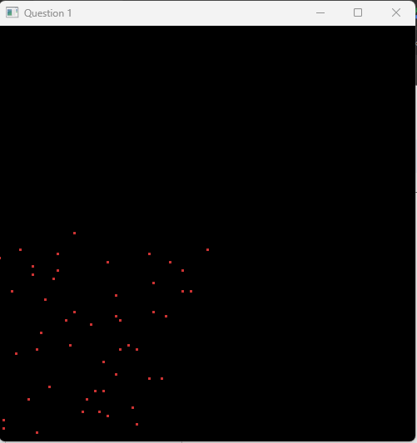

**Task 2**

**Input:**

from OpenGL.GL import *

from OpenGL.GLUT import *

from OpenGL.GLU import *

def draw_lines():

glLineWidth(4)

glBegin(GL_LINES)

# top triangle

#A->B

glVertex2f(275, 450)

glVertex2f(150, 300)

#B->C

glVertex2f(400, 300)

glVertex2f(150, 300)

#C->A

glVertex2f(400, 300)

glVertex2f(275, 450)

#for square part

#B -> D

glVertex2f(150, 75)

glVertex2f(150, 300)

#D -> E

glVertex2f(400, 75)

glVertex2f(150, 75)

#E ->C

glVertex2f(400, 300)

glVertex2f(400, 75)

#door

glVertex2f(255, 75)

glVertex2f(255, 150)

glVertex2f(295, 150)

glVertex2f(253, 150)

glVertex2f(293, 75)

glVertex2f(293, 150)

glEnd()

def draw_triangles():

glLineWidth(4)

glBegin(GL_TRIANGLES)

#left window

glVertex2f(175,250)

glVertex2f(175,205)

glVertex2f(235,205)

glVertex2f(175,250)

glVertex2f(235, 205)

glVertex2f(235, 250)

#right window

glVertex2f(315, 250)

glVertex2f(315, 205)

glVertex2f(375, 205)

glVertex2f(315, 250)

glVertex2f(375, 205)

glVertex2f(375, 250)

glEnd()

def draw_points(x,y):

glPointSize(5)

glBegin(GL_POINTS)

glVertex2f(x,y)

glEnd()

def iterate():

glViewport(0, 0, 500, 500)

glMatrixMode(GL_PROJECTION)

glLoadIdentity()

glOrtho(0.0, 500, 0.0, 500, 0.0, 1.0)

glMatrixMode (GL_MODELVIEW)

glLoadIdentity()

def showScreen():

glClear(GL_COLOR_BUFFER_BIT | GL_DEPTH_BUFFER_BIT)

glLoadIdentity()

iterate()

glColor3f(1.0, 1.0, 1.0)

draw_lines()

draw_triangles()

draw_points(282,110)

glutSwapBuffers()

glutInit()

glutInitDisplayMode(GLUT_RGBA)

glutInitWindowSize(500, 500)

glutInitWindowPosition(0, 0)

wind = glutCreateWindow(b"Question 02")

glutDisplayFunc(showScreen)

glutMainLoop()

**Output:**

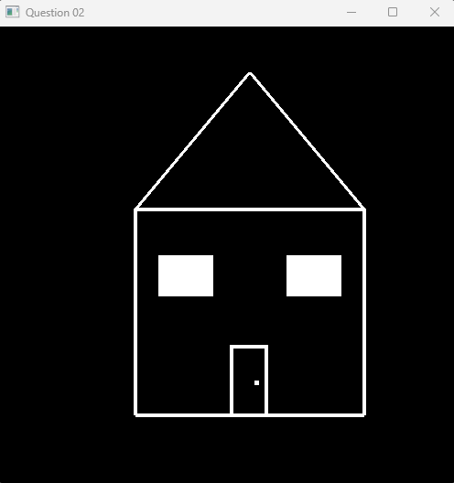

**Task 3**

**Input:**

from OpenGL.GL import *

from OpenGL.GLUT import *

from OpenGL.GLU import *

def draw_lines():

glLineWidth(3)

glBegin(GL_LINES)

#2

glColor3f(0.4, 0, 0)

glVertex2f(15, 500)

glVertex2f(60, 500)

glVertex2f(60, 500)

glVertex2f(60, 450)

glVertex2f(60, 450)

glVertex2f(15, 450)

glVertex2f(15, 450)

glVertex2f(15, 400)

glVertex2f(60, 400)

glVertex2f(15, 400)

#1

glColor3f(0.4, 0.2, 0)

glVertex2f(95, 475)

glVertex2f(120, 500)

glVertex2f(120, 500)

glVertex2f(120, 400)

glVertex2f(140, 400)

glVertex2f(95, 400)

# 1

glColor3f(1, 0, 1)

glVertex2f(165, 475)

glVertex2f(190, 500)

glVertex2f(190, 400)

glVertex2f(190, 500)

glVertex2f(165, 400)

glVertex2f(210, 400)

#0

glColor3f(0, 0.4, 0)

glVertex2f(240, 500)

glVertex2f(285, 500)

glVertex2f(285, 400)

glVertex2f(285, 500)

glVertex2f(240, 400)

glVertex2f(285, 400)

glVertex2f(240, 500)

glVertex2f(240, 400)

#1

glColor3f(0.4, 0.4, 1)

glVertex2f(315, 475)

glVertex2f(340, 500)

glVertex2f(340, 500)

glVertex2f(340, 400)

glVertex2f(315, 400)

glVertex2f(360, 400)

#1

glColor3f(0.8, 0.8, 0.8)

glVertex2f(390, 475)

glVertex2f(415, 500)

glVertex2f(415, 500)

glVertex2f(415, 400)

glVertex2f(390, 400)

glVertex2f(435, 400)

#6

glColor3f(1, 0, 0.5)

glVertex2f(465, 500)

glVertex2f(510, 500)

glVertex2f(465, 400)

glVertex2f(465, 500)

glVertex2f(510, 400)

glVertex2f(465, 400)

glVertex2f(510, 450)

glVertex2f(510, 400)

glVertex2f(465, 450)

glVertex2f(510, 450)

#1

glColor3f(1, 0.647, 0)

glVertex2f(540, 475)

glVertex2f(565, 500)

glVertex2f(565, 500)

glVertex2f(565, 400)

glVertex2f(540, 400)

glVertex2f(585, 400)

glEnd()

def iterate():

glViewport(0, 0, 600, 600)

glMatrixMode(GL_PROJECTION)

glLoadIdentity()

glOrtho(0.0, 600, 0.0, 600, 0.0, 1.0)

glMatrixMode (GL_MODELVIEW)

glLoadIdentity()

def showScreen():

glClear(GL_COLOR_BUFFER_BIT | GL_DEPTH_BUFFER_BIT)

glLoadIdentity()

iterate()

draw_lines()

glutSwapBuffers()

glutInit()

glutInitDisplayMode(GLUT_RGBA)

glutInitWindowSize(600, 600)

glutInitWindowPosition(0, 0)

wind = glutCreateWindow(b"Question 3")

glutDisplayFunc(showScreen)

glutMainLoop()

**Output:**

